User guide:

* When you open the project, you will see a file name “posts.csv” in the resource folder like below. In this file, I already added some sample records of posts that you want to add. If you need to add anything else except my sample, please create a new line and follow my sample record.

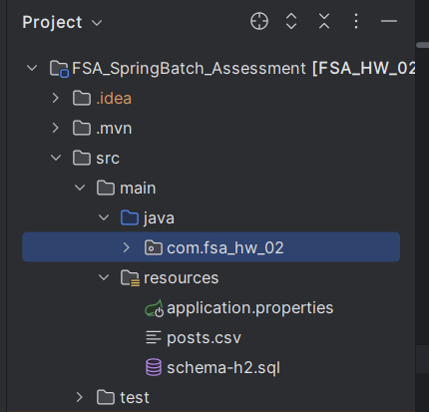

* Using Postman to run a batch job:
* API to run batch job to add new post: Please choose the method to POST and use this endpoint http://localhost:8080/api/batch/start like the picture below:

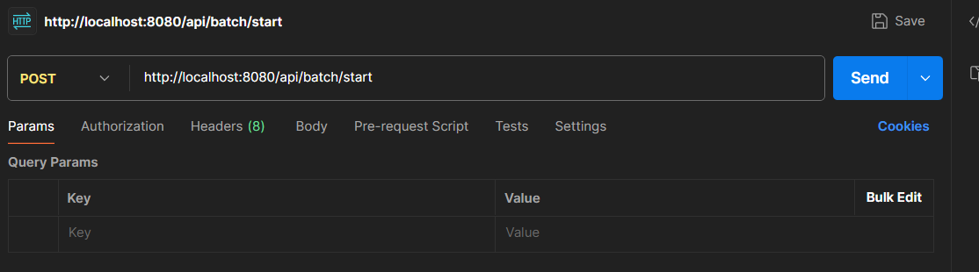

* API to check that batch job is run completed or not: Choose method GET and use this endpoint: http://localhost:8080/api/batch/jobs

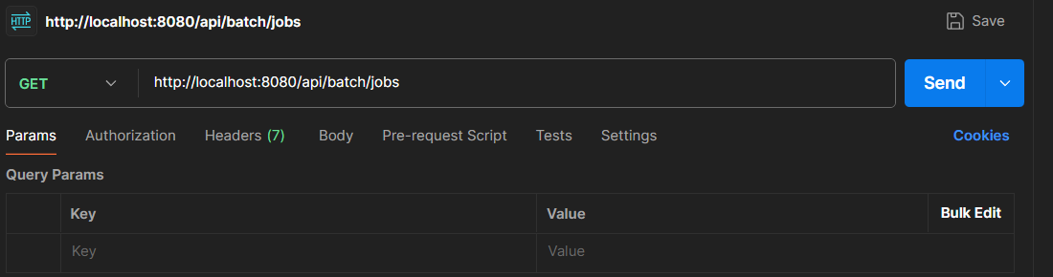

* API to check all posts: When you check that the batch job is completed, you can use this API to get all posts and check whether all the records of posts that you add to the CSV file exist or not. Choose method is GET and use this endpoint <http://localhost:8080/api/posts>

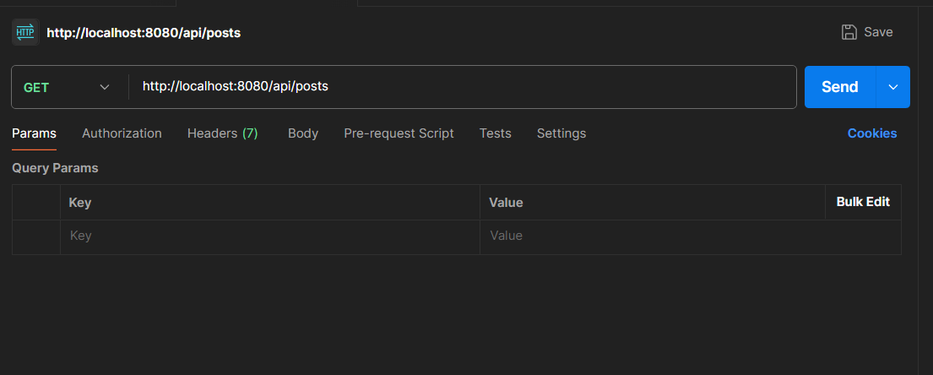

* If any of that record does not exist, that means there are some errors with that record. This will be provided in the file error_report.

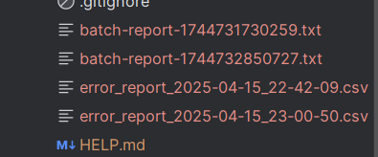

* You can also check the information on how many records are processed, how many are successful, and how many failed in the file batch report
* 